DetectLogPro


Table of Contents
Maps 1
Adding Finds 2
URL Maps 3
Finds Tab 4
Pictures Tab 5
Overlays 7
Reports 7
2D Label Printing 8

Introduction
DetectLogPro is an advanced tool for Metal Detectorists giving you a place to record and manage your finds, and with the Premium upgrade, plan trips using historic maps and Lidar, and reports and labels. The premium edition also provides synchronisation with your Google Drive account to back up data and share with other devices you may have.

Maps
The Maps screen is the default and allows you see all your finds where you found them (centre of the thumbnail). Ribbon icons from left to right are:
- Cloud Sync (currently only Google Drive) – connect in the Settings screen if using for first time.
- Overlays visible. Overlays are only available when one of the ‘URL’ maps is selected, not the native Google maps. If you are not on one of these map types or don’t have loaded Overlays (see Overlay section), then this icon wont appear.
- Route Tracking. This is not visible on desktop versions (see the mobile screen shot lower down), but when on will track you and stop automatically if you start travelling faster than a human is designed to go (so will stop when you drive home). When it stops, the route is saved and can only be seen by toggling ‘show routes’ in the menu. Note: If route tracking is erratic on your phone, make sure that you have allowed the app to always run in the background (battery optimisation), and also in location services.
- Filter. This option allows you to select what is loaded from your database. When data is filtered the icon changes to solid (in case you wonder where your finds have gone!)
- Menu. Allows you to select the map you prefer, manage route tracks, and access Settings
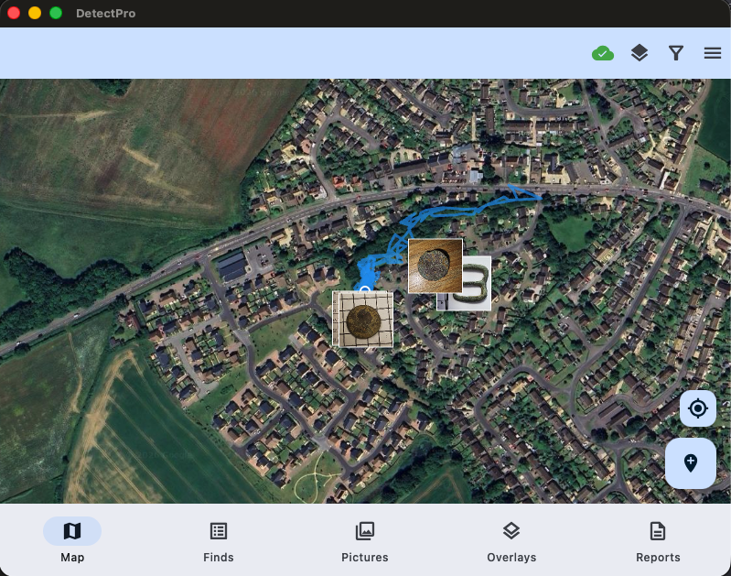
Figure 1Desktop view of map screen
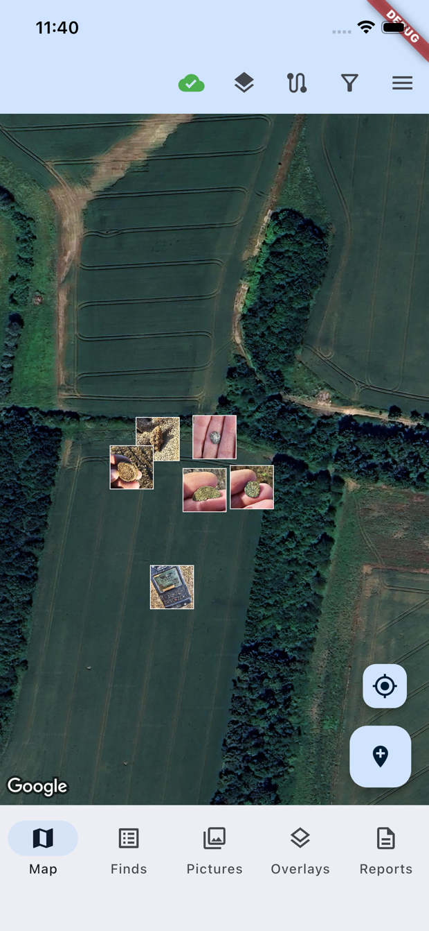
Figure 2 Mobile view of map screen

Adding Finds
Finds can be added in the field by pressing the waypoint icon, but also by selecting a point on the map and long pressing to get the add find prompt.
By default, the Add find form keeps things simple so you can quickly capture the name, target ID and a picture. But you can expand out the form to capture more information if needed (or when back home).
Note if you add a PAS reference against your find, when viewing your find a button will automatically be enabled that will allow you to launch the page on finds.org.uk (If you are not in the UK but have a similar system you can edit the URL in the Settings screen to use your countries search)

URL Maps
In the Settings screen it is possible to add URL to XYZ tiles URL’s. In the UK, the best source is the national library of Scotland maptiler service (https://cloud.maptiler.com/tiles/ ) where you can sign up for free and copy the URL into the appropriate field on the settings form (see Figure 5 Configuring the 'URL' maps below).

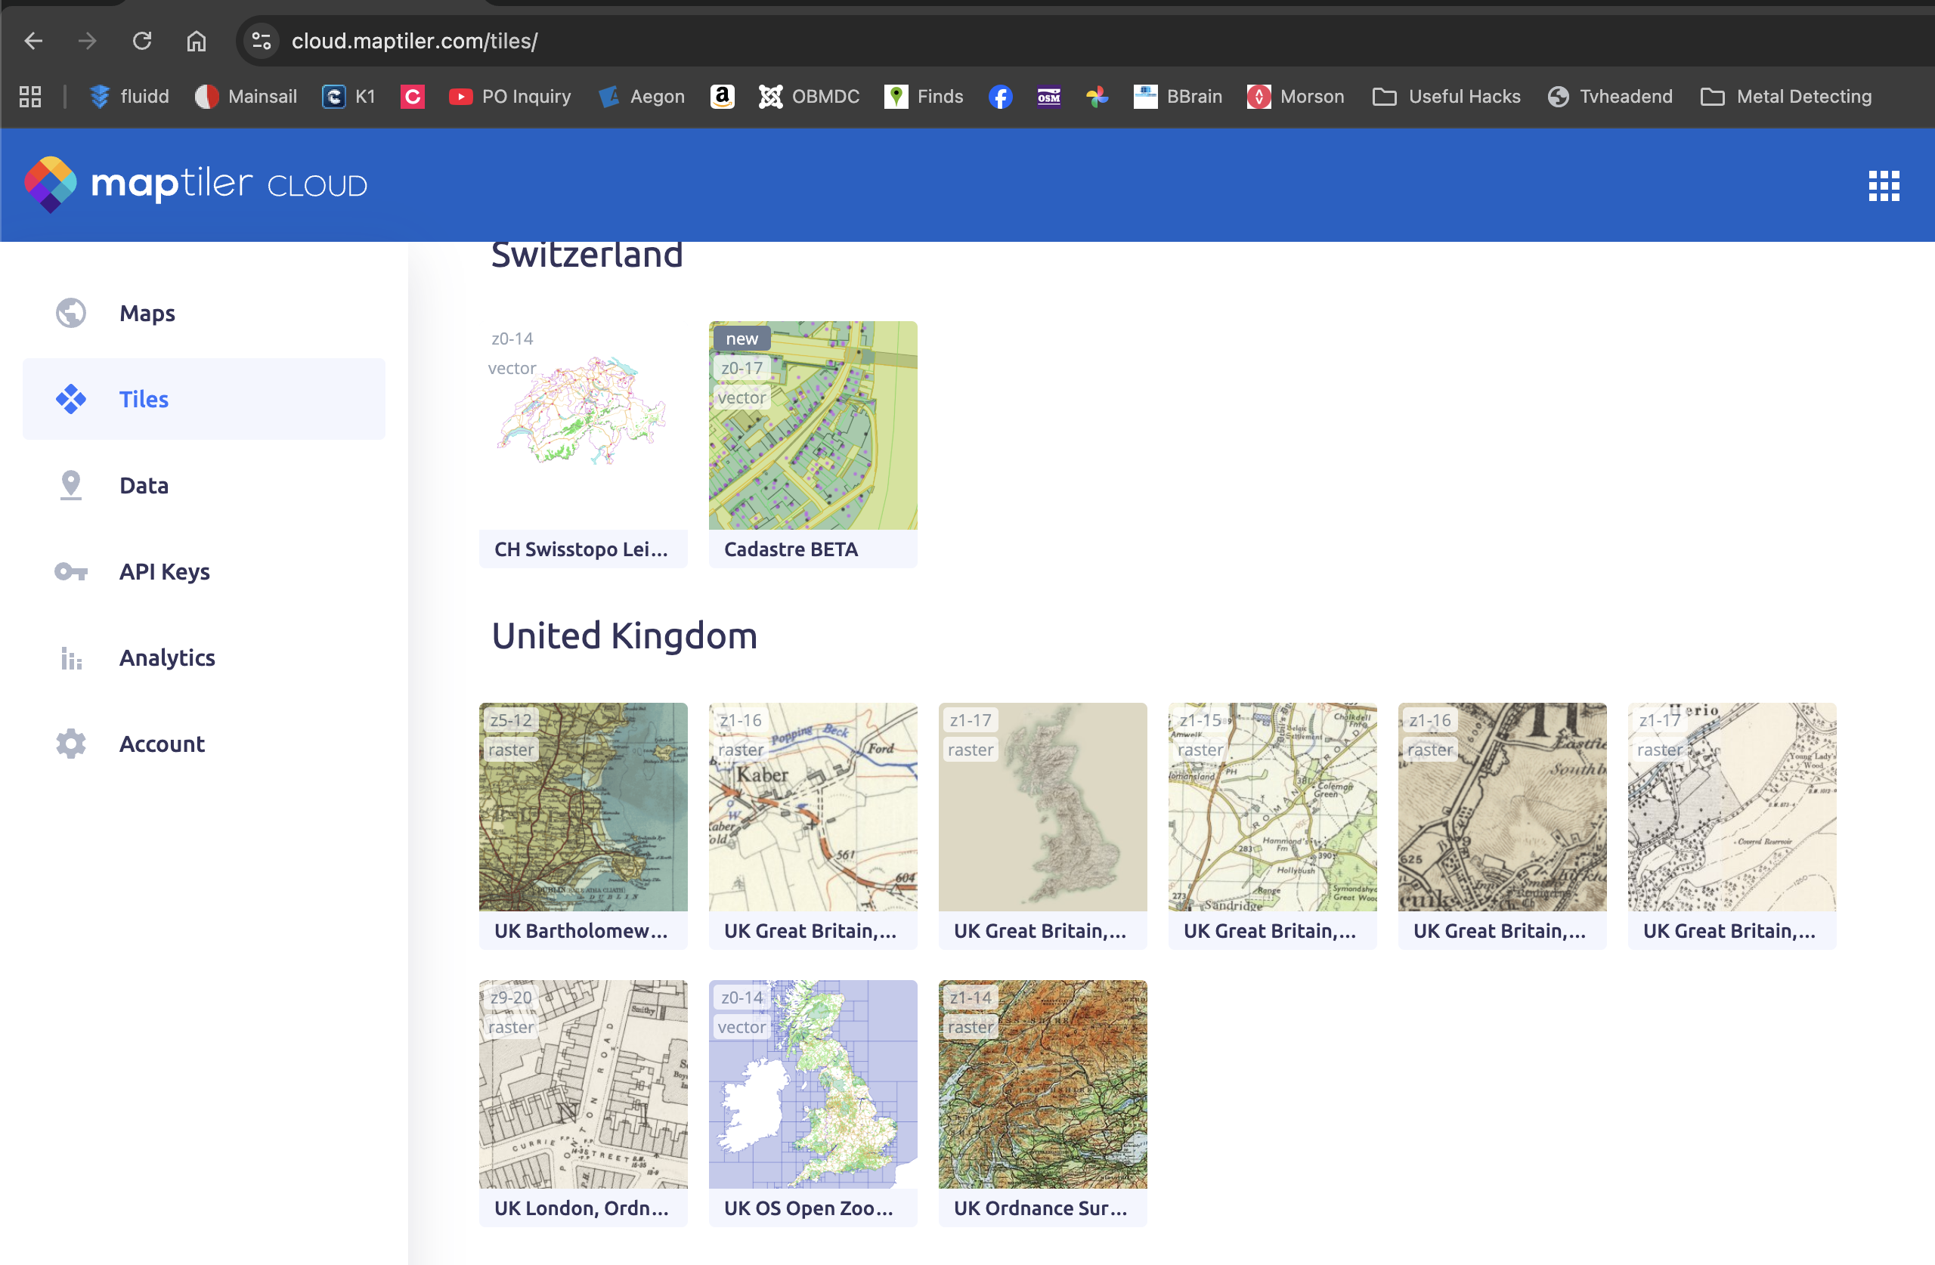
Figure 3 NLS Maptiler maps
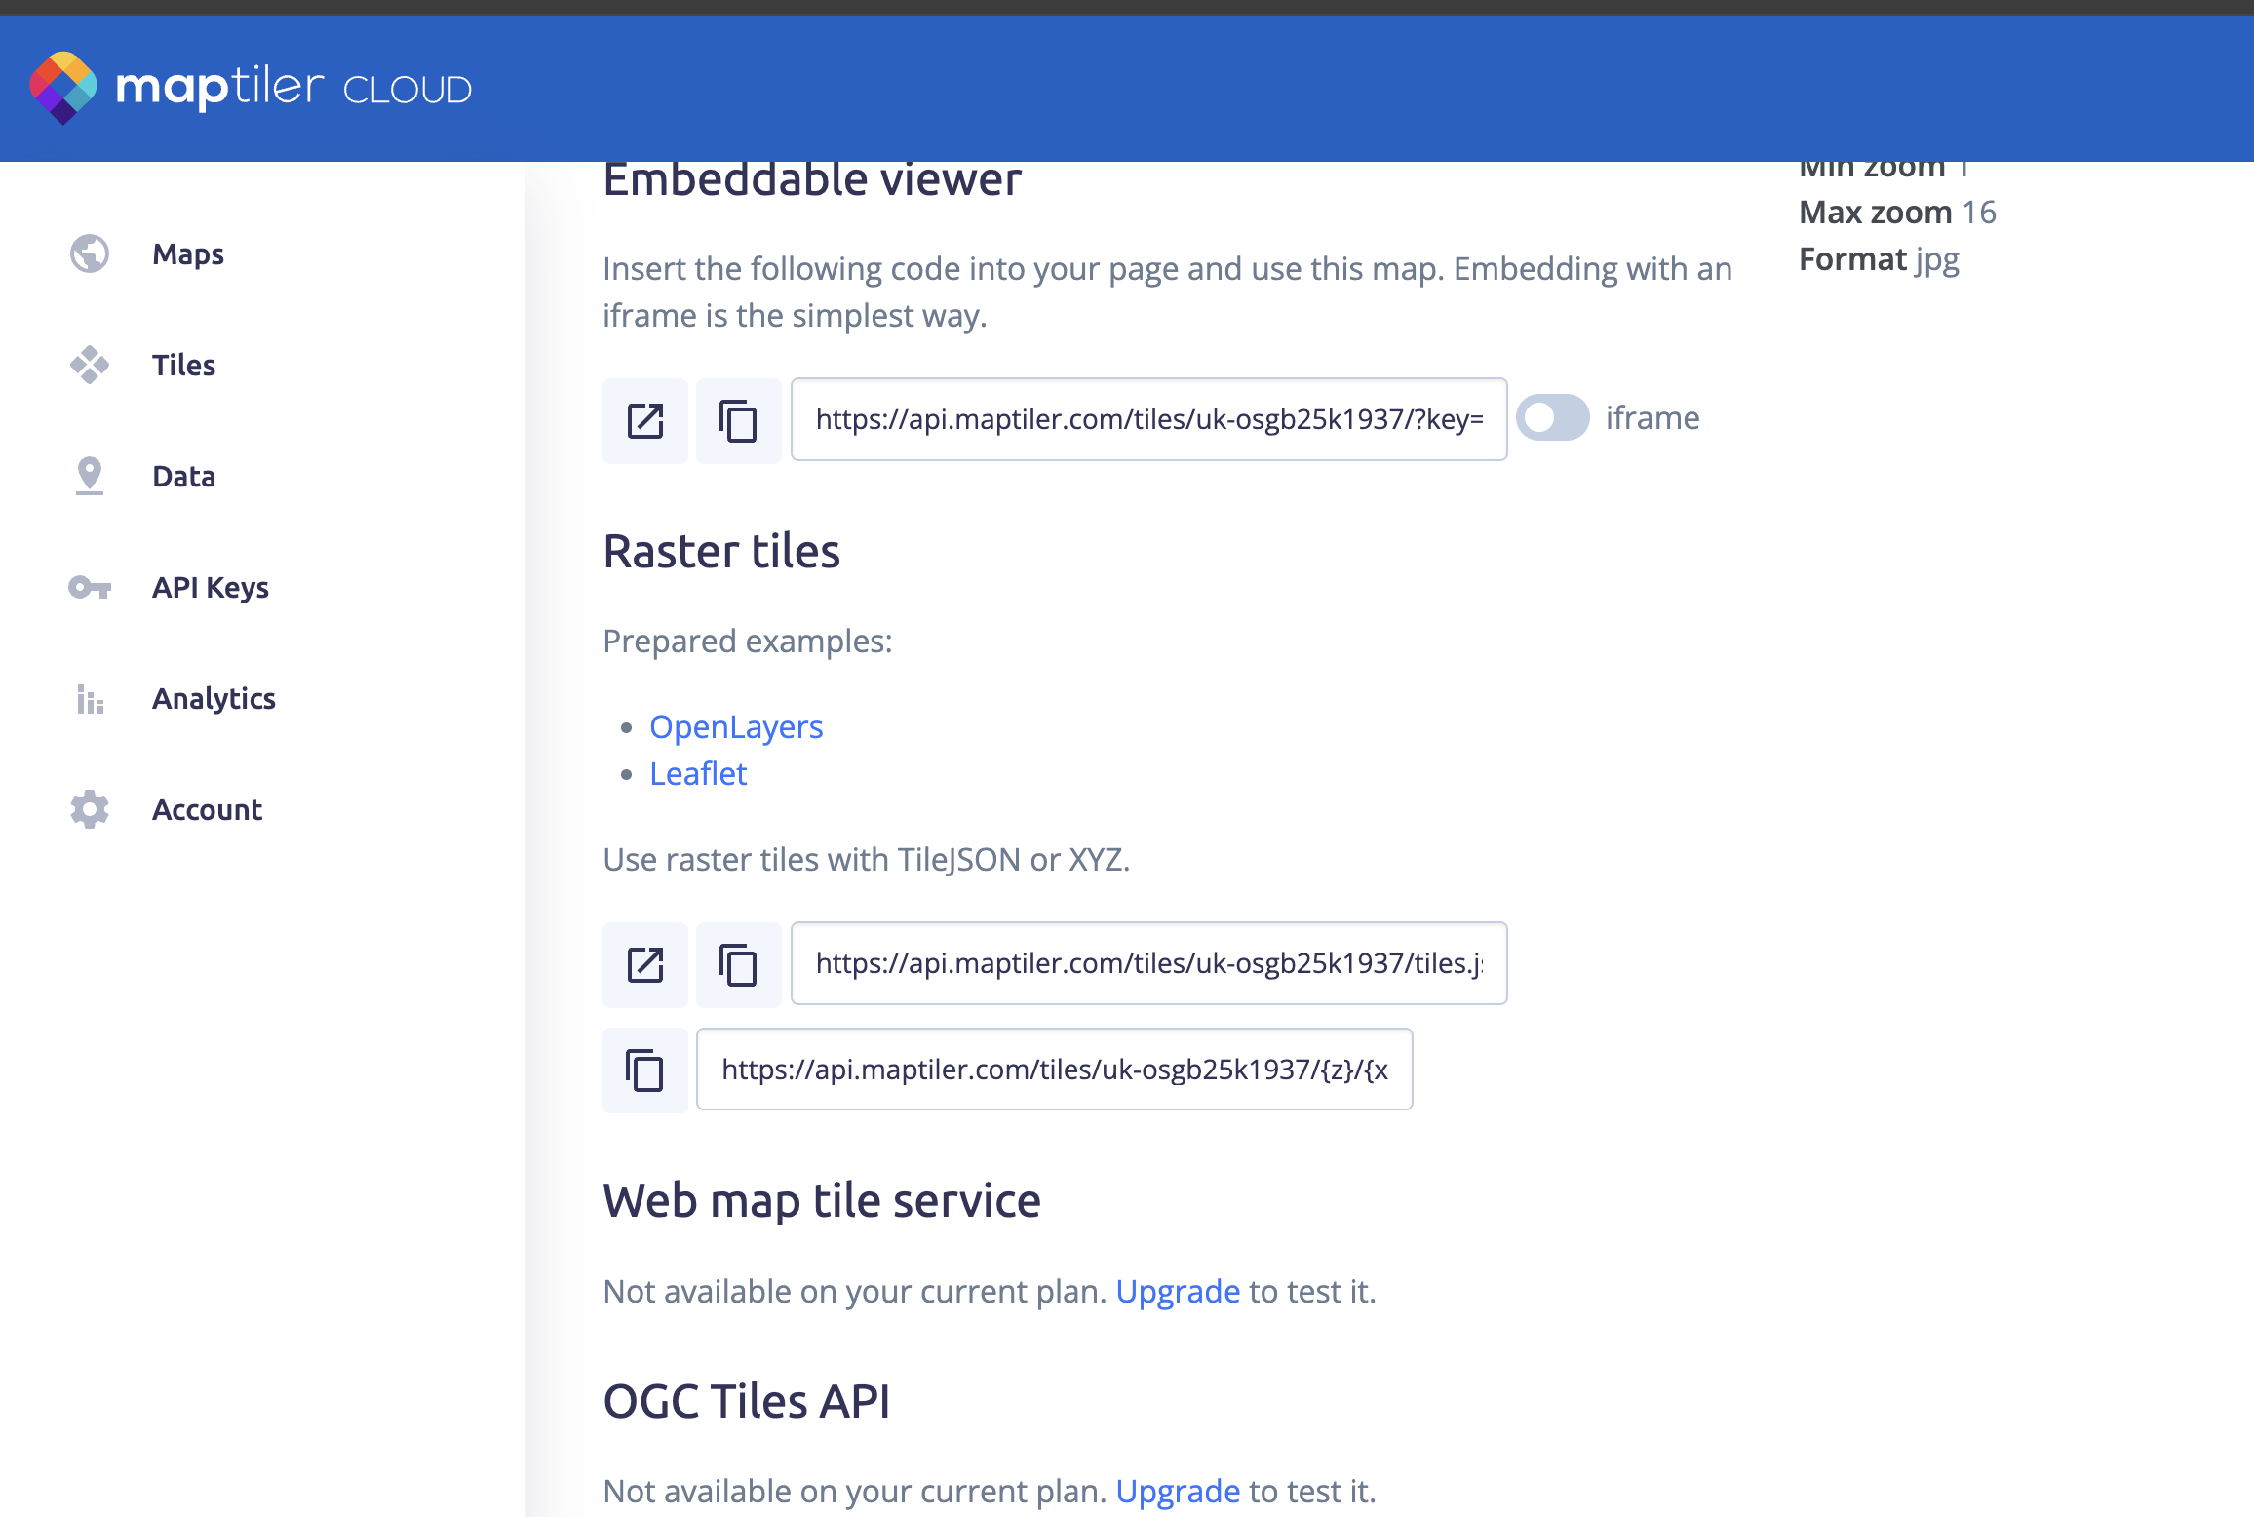
Figure 4 Raster tile URL (you need the 2nd one to paste into the settings screen)
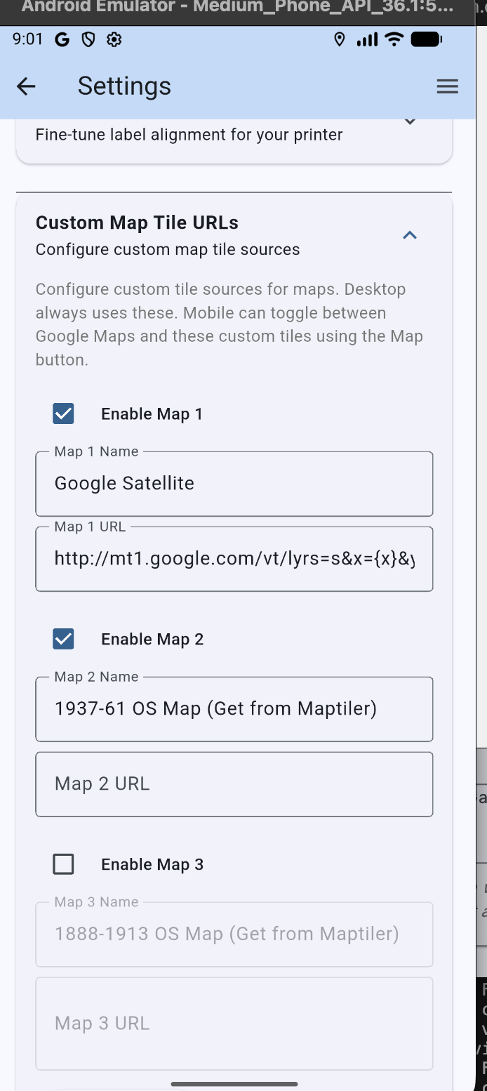
Figure 5 Configuring the 'URL' maps

Note: When selecting a URL map, it may take a few seconds to reload your finds. Also you may have to zoom out to ‘catch’ the highest level of zoom for that tile set, and then zoom back in (this also applies to Lidar Overlays).

Finds Tab
The Finds tab is where you can search for Finds, share with friends and delete the duds (up until you sync this can be reversed by filtering on deleted finds in the map tab). It is possible to add new finds from this screen, but this can also be done from the map screen.
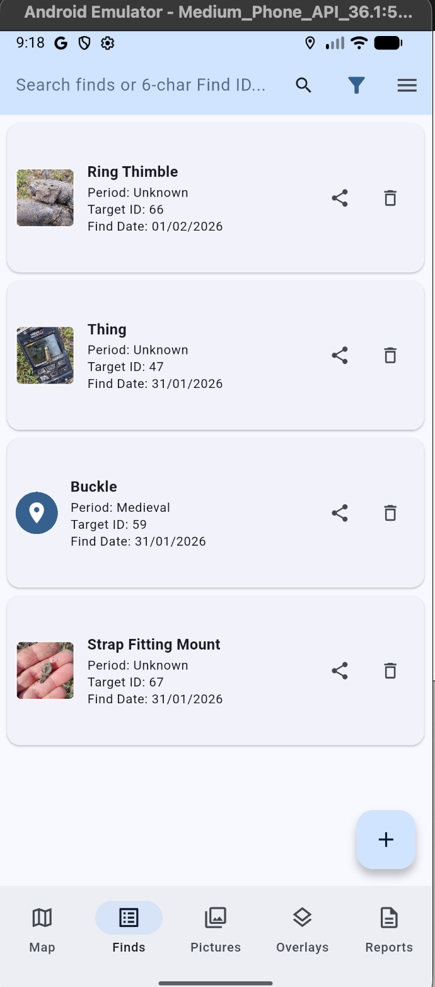
Figure 6 Finds Tab

Pictures Tab
The Pictures tab shows all pictures and from where you can click to open the find record and see the full quality image.
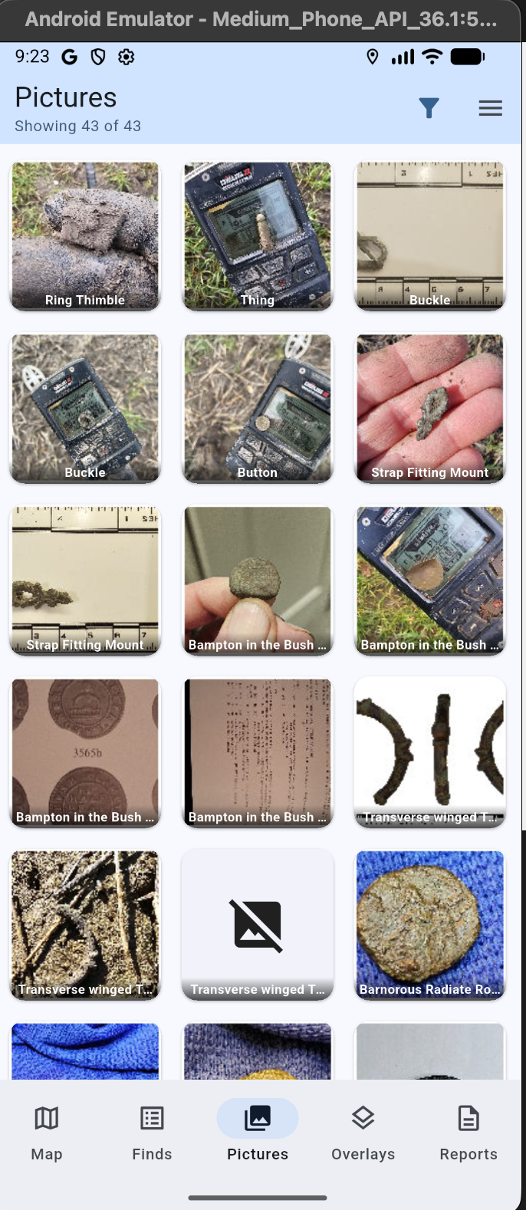
Figure 7 Pictures tab

Overlays
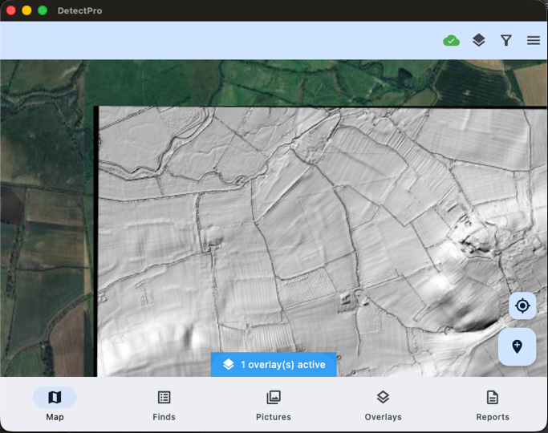
Figure 8 Lidar overlay on the Map screen
The app can support overlays in the format of MBTiles files. These can be exported from the excellent open source QGIS application. You can also download from the PageTech web site a simple tool that will convert TIF files downloaded from the UK DEFRA website (as seen above).
On desktop and Android versions you can load MBTiles files directly from the Overlay tab. Apple iOS (iPhone and iPad), you will need to use the Apple Files app to share them with DetectLogPro.

Reports
In addition to printed reports the app also offers counts on hashtags which you can record against each find. These totals are for the current filter (see map section), so can be used to report for instance on the finds this year. The PAS count is driven by the PAS field on the Finds form.
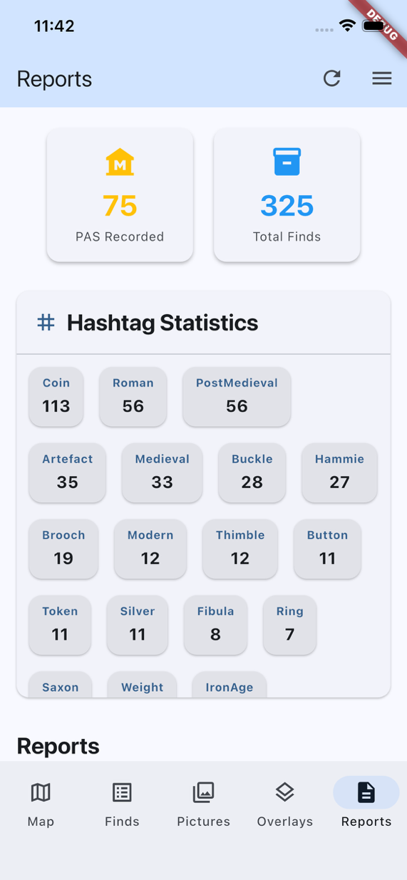
Several standard reports can be printed. Apart from the Storage & CSV reports you need to select finds first in the Finds tab (press and hold to start selection then tap as many as you need to print).

2D Label Printing
The 2D labels are intended to print on 3 x 7 standard labels. The 2D barcode can be scanned by the mobile camera and will launch the app, finding the record in the database.
To print labels, you will need to print test prints (I recommend on paper rather than labels themselves), and adjust the settings to match your device (unfortunately I have found the mobile prints smaller labels compared with the Mac) and printer.
Label Printing configuration is in the Settings section and these values I found worked with my Mac and Brother printer:
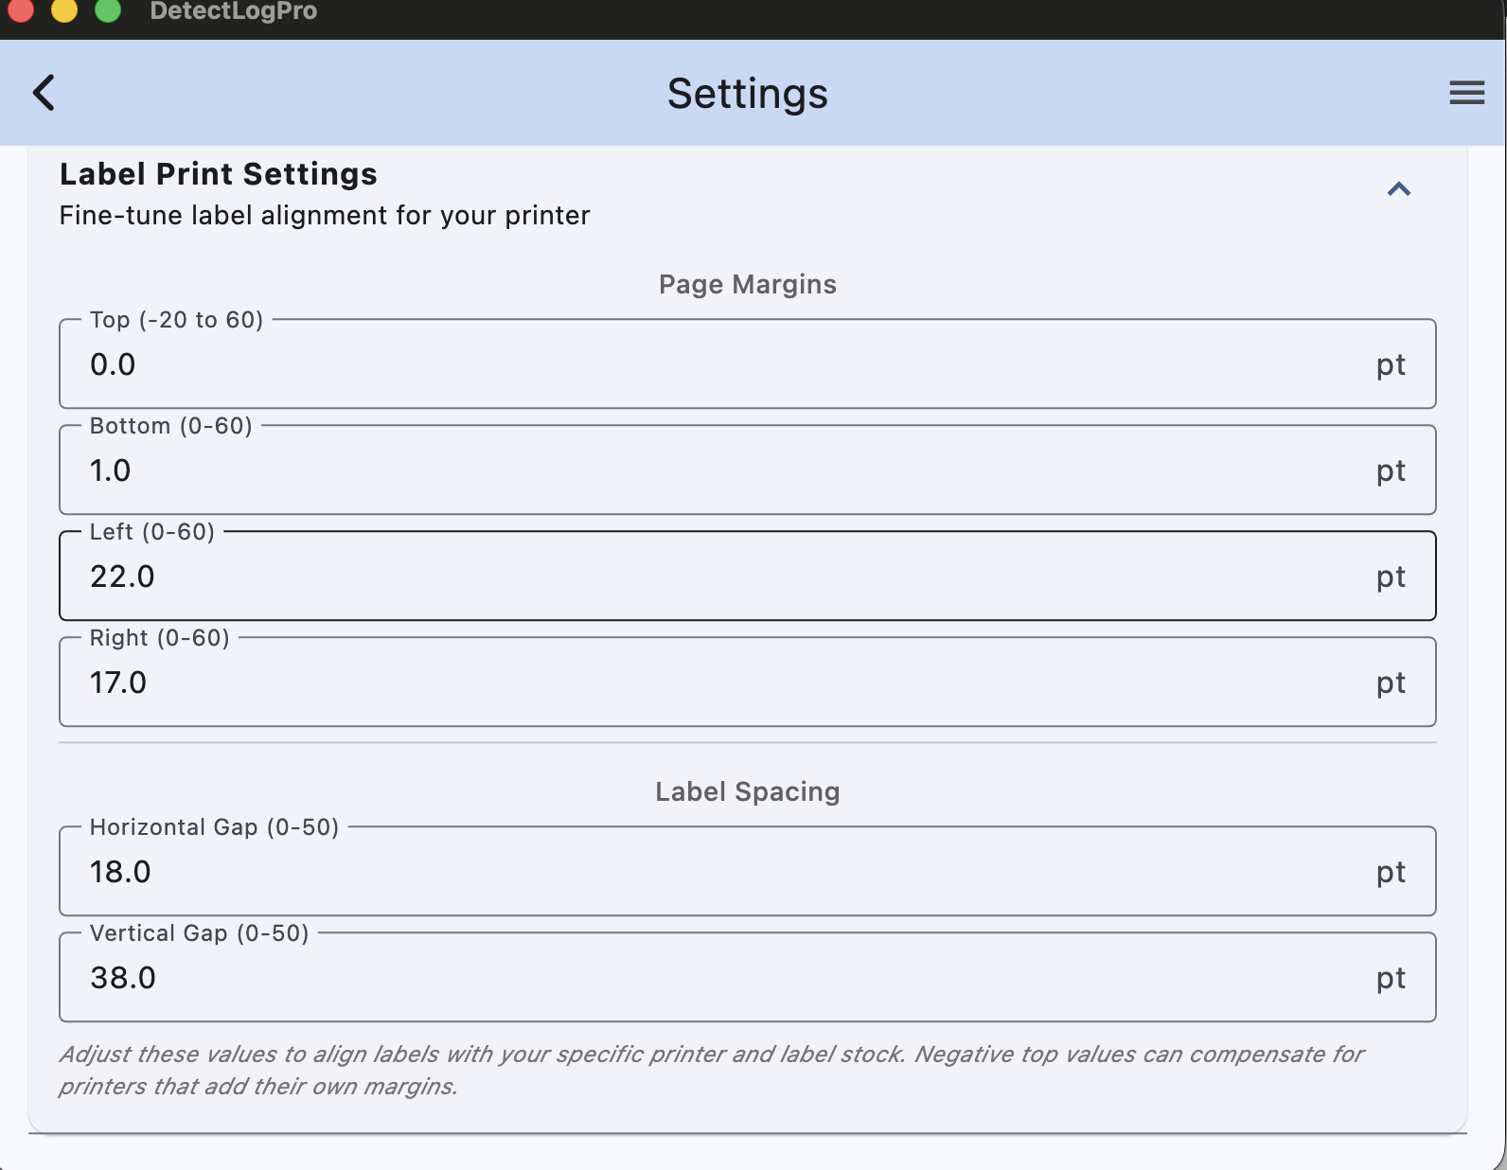
By comparison I had to set a Horizontal gap of 40 for the same report on a Samsung S23 Ultra.
To save label stock this report can start printing at the next space on your label sheet by specifying which label it should start printing at.

Import from GPKG
It is possible to import your finds from other apps that support export to GPKG (these contain the finds record and photos. For desktop and Android this can be done via the section in the Settings screen. iOS devices you will need to use the apple Files app to find your export and share with DetectLogPro. It is possible to select more than one GPKG file at a time. The app will not allow you import the same file twice, so it is safe.

Cloud Sync
First time you intend to Sync you need to connect up to your Google Drive. It is possible for the DetectLogProSync Folder to be shared with others if you want to work as a team (their finds will show with a blue surround on the map screen if you each set a different user name).
First time use you can either export all of the local database with the cloud or import all from the cloud. In the latter case this will delete everything on your local database and replace with records from the cloud – so take care! Exporting all to the cloud will push a fresh record of everything in your database to the cloud folder, which in turn will trigger a refresh in other devices.
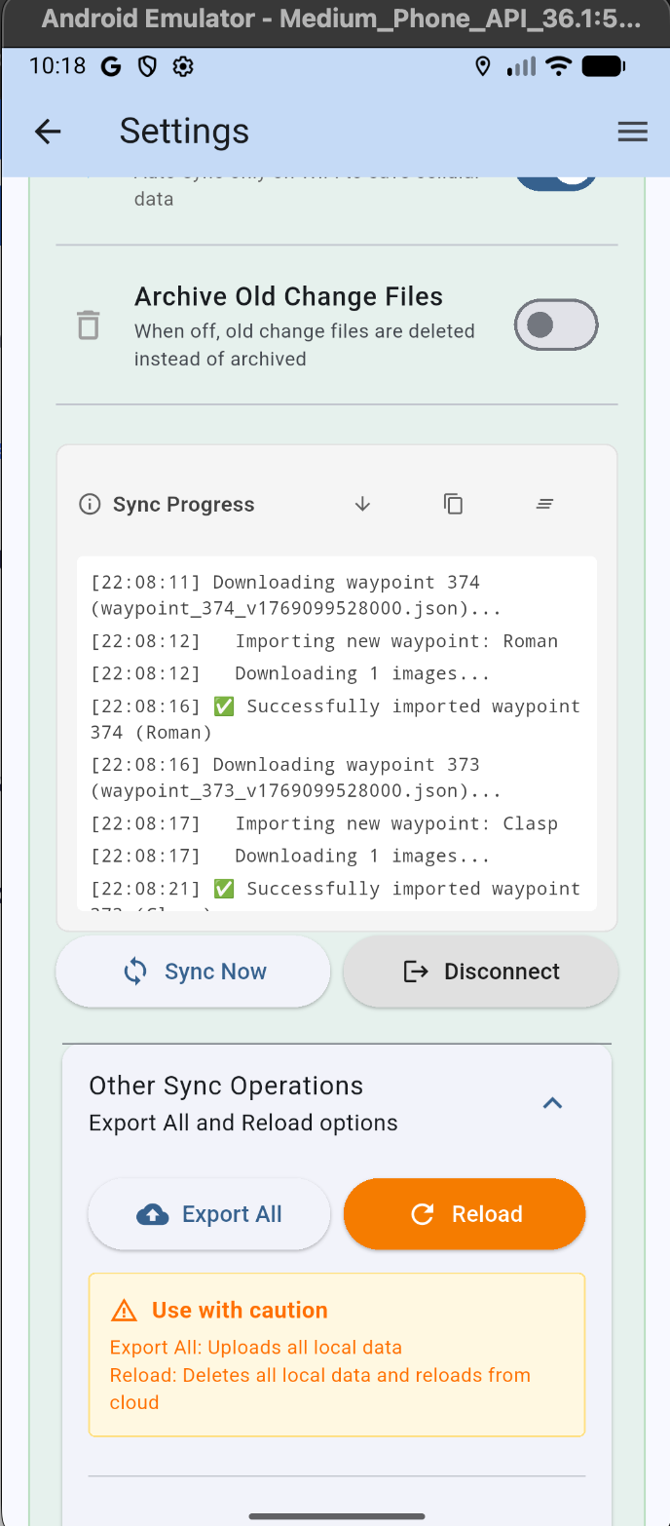
Figure 9 Cloud sync in Settings screen

Frequently Asked Questions
Issue | Solution
Route tracking only appears to record a point when the phone is turned on (straight lines between points) | Your phone us probably stopping the app from running when screen is off as modern phones are aggressive when trying to save battery power. Check for battery optimisation or sleeping apps in your phones settings.
I cannot see the overlay toggle icon | You need to be viewing a URL map AND have a MBTiles file loaded in Overlay tab.
I cannot see my Lidar overlay | Check the show overlay toggle is not off, and also try zooming in or out. The MBTiles export has a limited set of zoom levels and the app needs to be in one of these to ‘find the tile’. It can zoom closer as it can stretch the last tile.
On my iPhone I cannot get to where I saved my MBTiles or GPKG files | Try using the Apple files app and ‘Share’ with DetectLogPro. This will copy the file to a space where DetectLogPro can see it and automatically load it.
Maps wont load | Check your data connection. If you are going to a location with poor data signal, try pre-loading map tiles at home by zooming into the area you plan to visit.
My finds have disappeared! | Check you haven’t a filter active.
Cloud sync keeps stopping | Unfortunately, it is only possible to share data with your Google Drive whilst the app is open (showing on the screen). The app will detect sync has stopped and prompt you to resume when it regains focus. If you are doing a full load (or export), it is best to leave you phone with screen on (turn of screen saving). 300 records for me took 30-40 minutes to transfer. Fortunately dig updates are much quicker!
I want to add a photo and make it the default? | Goto the find and click the edit icon, you can then add photo’s using camera or gallery. You can also chnge the order by grabbing the bar at the bottom of the photo. If you have just added the photo you may need to save the record and re-edit to move the new photo to the front.
Where are my finds stored? | Along with a database on your device, finds are stored in the DetectLogProSync folder on your cloud storage. Each waypoint has a text record with your data, and there is also a subfolder ‘Images’ that contains all your photos. Data is totally in your control and PageTech Ltd has no access to it.
How many records are stored on my phone? | At the bottom of the Settings form there are stats showing memory and storage used plus total number of finds and total images.

